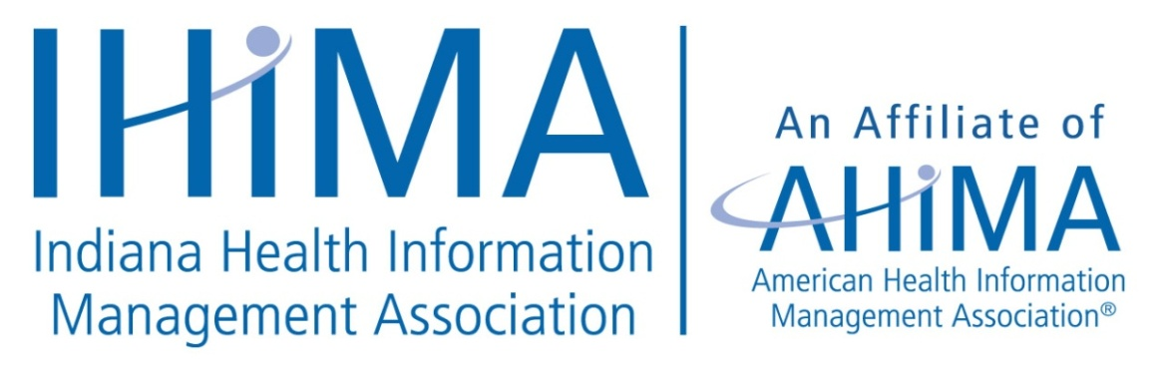

**Student Liaison Job Description**

**Scope of Responsibility**

Observes and familiarizes oneself with the Indiana Health Information Management Association and the IHIMA Executive Board activities. Performs the following functions: communicate with students and acts as a liaison between the students and board; participate in board meetings; coordinate student volunteers at the IHIMA Annual Meeting. The student would be a non-voting member at the IHIMA Executive Board Meeting. The term will run from July – June, with one serving a one year term and the other serving a two year term.

**Scope of Authority**

The Student Liaisons report to the IHIMA President and are selected by the IHIMA Executive Board. The position is responsible for communicating and serving as a board representative to the HIT/HIM students within the state and obtaining input from the students. The Student Liaison(s) work with the Annual Meeting Committee, Member Engagement, the Communications Chairperson, President and the Central Office Coordinator.

**Specific Duties and Responsibilities**

* Plan communication with Indiana HIT/HIM students
* Report to the IHIMA Executive board concerns and activities of students
* Submit newsletters items/topics to the Communication Chairperson
* Coordinate student volunteers for the IHIMA Annual Meeting including set-up, introducing speakers, distributing handouts as appropriate and other duties as assigned.

**Qualifications**

Student of an Indiana CAHIIM accredited HIT or HIM program; is able to attend board meetings and the IHIMA Annual meeting. The applicant must be a resident of the state of Indiana and he or she must be an active AHIMA/IHIMA member. Volunteer experience in an HIM setting is preferred.

Updated October 2012; revised 10/13, revised 4/16, revised 5/22